

**DEVELOPMENT REPORT OF THE FLAMINGO BOOK STORE**

**APPLICATION**

**WORKED ON BY**

**SENKOOTO DAVIS JOHN 2020-B072-20123**

**Introduction**

The flamingo book store is a digital platform that can also be called online library ans is an online dataset of objects that can include text , images ,still images and lets you access books, magazines, and other resources online. It's efficient and convenient in that you can read or study anytime, anywhere, as long as you have an internet connection. it saves space and reduces paper waste. The flamingo book store application is basically like a virtual library where one can access books, magazines,stories and other resources online. It's great because you can read or study whenever you want, as long as you have internet.

**Objectives**

The main goal of the flamingo book store application is to provide e access to a wide range of resources easily, and support research and education. It aims to make information available to users at any time, regardless of their location, and to encourage digital literacy and the use of technology for learning purposes. It also enhances user experience via a good user interface.

The flamingo book store application aims to reduce the environmental impact associated with traditional libraries by minimizing the use of physical resources such as paper and energy.

**Features and functionalities**

1. Online Access: You can access the e-library from anywhere with an internet connection.

2. Digital Collection: It offers a vast collection of e-books, audiobooks, journals, and other digital resources.

3. Search: You can easily search for specific titles, authors, or subjects to find the materials you need.

4. Downloads: You can read or download e-books and other resources digitally, eliminating the need for physical copies.

5. Personalization: flamingo book store application allow you to create personalized reading lists and track your reading history.

6.Acquisition and budget management: The system assists in in the acquisition process and managing purchase orders

7. Accessibility: flamingo book store application often provide features like adjustable font sizes, text-to-speech, and screen reader compatibility for users with disabilities.

8. Remote Renewal and Returns: You can renew borrowed items or return them remotely, without the need to physically visit the library.

9. Collaboration and Sharing: Some e-library systems enable users to share notes, highlights, and recommendations with others.

10. Online Support: You can access online support, FAQs, and tutorials to help you navigate and use the flamingo book store application effectively.

**User Experience**

Interacting with the flamingo book store application is quite straightforward. Once one logs in to the system, they can use the search bar to find specific books or browse through different categories. When you find a book you're interested in, you can click on it to read a summary or check out reviews. If you want to download the book, you can simply click on the download button or add it to your reading list. You can access your downloaded books from your account and start reading them right away.

The flamingo book store application also allow you to customize your reading experience, like adjusting font sizes or highlighting text. It's all designed to make your reading experience enjoyable and convenient

**Development and Maintain of an e-library system.**

1. Application development: The flamingo book store application requires mobile computing technologies like Android studio and Java to create the user interface and functionality.

2. Database Management: A robust database management system is needed to store and organize the digital resources, user information, download history, and other relevant data.

3. Networking: A stable network infrastructure is essential for users to access when downloading the application.

4. Security Measures: Implementing security protocols including encryption, authentication, and access control is crucial to protect user data and prevent unauthorized access.

5. Content Management System: A content management system (CMS) can help manage and update the digital resources, allowing librarians or administrators to add, remove, or modify content easily.

6. User Management: A user management system is needed to handle user registration, authentication, and account management.

7. Mobile Applications: Developing mobile applications for iOS and Android platforms can enhance accessibility and provide a seamless reading experience on mobile devices.

8. Regular Maintenance: Ongoing maintenance is necessary to ensure the system's stability, fix bugs, apply security patches, and update the software and hardware components.

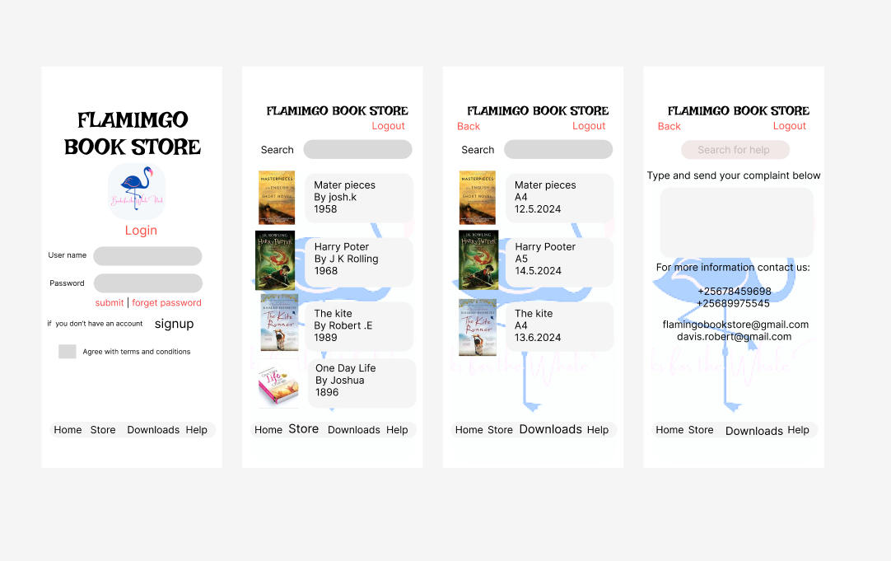

**Implementation plan for deploying the e-library system:**

1. Requirements Gathering: Gather detailed requirements from stakeholders,to test functionality, user experience, and technical specifications.

2. System Design: Creating a comprehensive system design, including database schema, user interface wireframes, and architectural components.

3. Development: Develop the flamingo book store application using the chosen technologies and frameworks. This includes front-end development for the user interface, back-end development for the server-side logic, and integration with the database.

4. Testing: Conduct thorough testing to ensure the system functions as expected. This includes functional testing, performance testing, and security testing.

5. Content Acquisition: Acquire the necessary digital resources for the e-library, including eBooks and audiobooks. This may involve partnerships with publishers or content providers.

6. Deployment: Deploy the flamingo book store application on a production server.

7. User Registration and Authentication: Implement user registration and authentication mechanisms to ensure secure access to the e-library system.

8. Data Migration: If migrating from an existing library system, plan and execute the migration of user data, download history, and other relevant information to the new e-library system.

